 | 26.10.14 Editors - Properties Editor - Particle Properties Tab - Emitter - Animation panel
Table of content
Animation panel 1
New 1
Action Selector 1
Fake User 1
Add 1
Remove 1

Animation panel
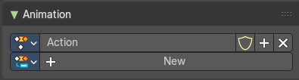
Animation panels are about the Animation Slots for scene wide animation clips.

New
Create a new action clip for the light, used in the Dopesheet Editor - Action Clip mode.

Action Selector
This selector allows users to manage actions associated with a particle system, ensuring that the correct animation data is applied.

Fake User
Assigns a "fake user" to the action, preventing it from being automatically deleted when it is
no longer in use.

Add
Make a copy of the current action, including all animation data.

Remove
Delete the selected action, removing it from the light source.

